# **Analysis and Mitigation Strategies for Hotel Booking Cancellations**

# Business Problem

Recently, both City Hotel and Resort Hotel have experienced a surge in booking cancellations. This has led to challenges such as reduced revenue and inefficient room occupancy. Thus, their main aim is to **decrease these cancellations to boost their revenue efficiency**. Our role is to provide comprehensive business guidance to help them tackle this issue.

This report primarily focuses on the analysis of hotel booking cancellations and other factors that don't directly impact their annual business revenue.

# Assumptions

1. There have been no significant events between 2015 and 2017 that would greatly affect the data we're using.
2. The data remains relevant and can effectively aid in strategizing for a hotel's potential plans.
3. There are no unexpected drawbacks for the hotel if it decides to implement any suggested strategies.
4. None of the proposed solutions are currently in use by the hotels.
5. The primary factor influencing revenue generation efficiency is the rate of booking cancellations.
6. When cancellations occur, rooms remain empty for the duration of the initially booked period.
7. Customers tend to cancel their hotel bookings within the same year they make the reservations.

# Research Questions

1. What factors influence the cancellations of hotel bookings?
2. How can we better manage and reduce hotel booking cancellations?
3. How can we support hotels in making decisions related to pricing and promotions?

# Hypothesis

1. More cancellations occur when prices are higher.
2. When there is a longer waiting list, customers tend to cancel more frequently.
3. The majority of clients are coming from offline travel agents to make their reservations.

# Analysis and Findings

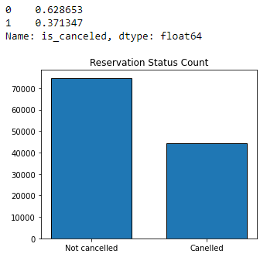

The bar chart provided indicates the proportion of bookings that were either canceled or retained. It's clear that a noteworthy quantity of bookings remains intact. However, a considerable 37% of customers opted to cancel their bookings, an occurrence that significantly influences the revenue of the hotels.

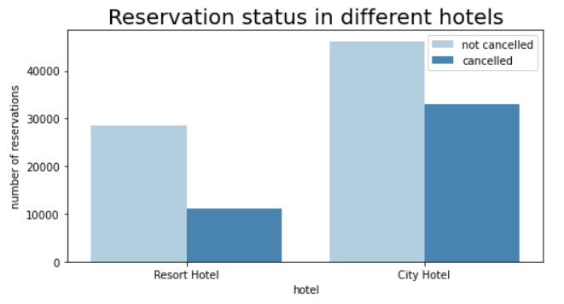

When juxtaposed with resort hotels, urban hotels appear to attract a higher volume of reservations. The reason could be that resort hotels might command higher prices compared to their city counterparts.

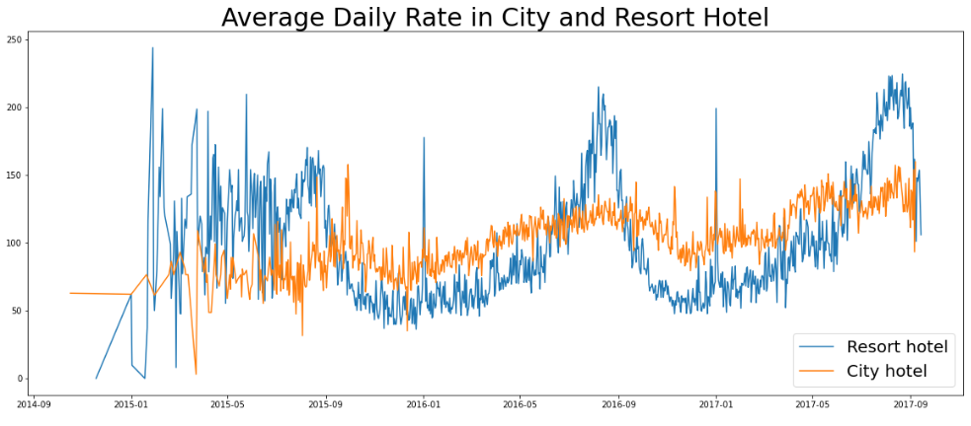

The line graph above shows that, on certain days, the average daily rate for a city hotel is less than that of a resort hotel, and on other days, it is even less. It goes without saying that weekends and holidays may see a rise in resort hotel rates.

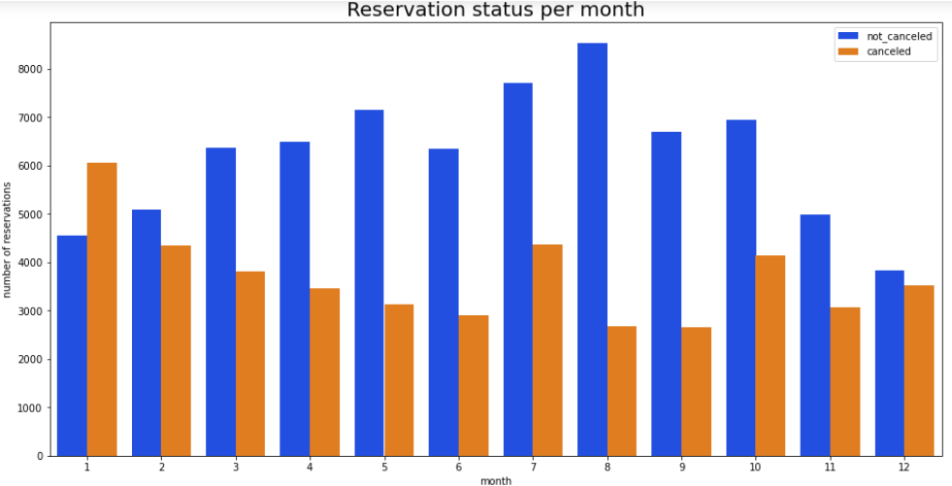

We created a bar chart that groups the months based on their reservation status to figure out which months have the most and least bookings. From what we can see, August has the highest number of both confirmed and canceled bookings. Interestingly, January has the highest number of cancellations.

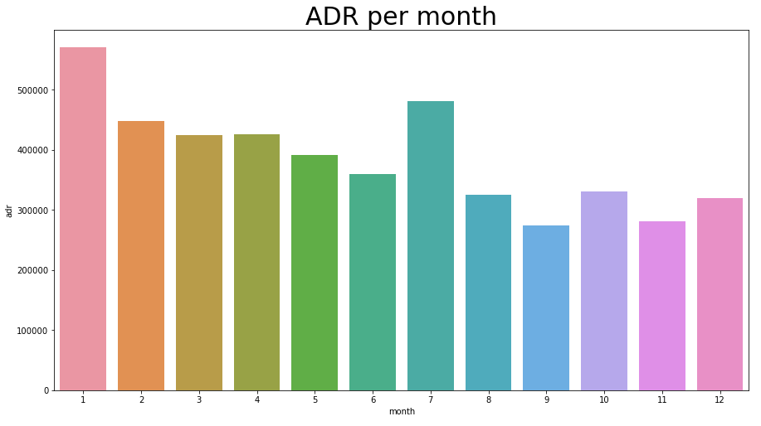

The bar chart shows that more people cancel their bookings when the prices are high and fewer do so when the prices are low. So, it seems like the main reason for cancellations is the price of the stay. Let's look at the country with the most cancellations. It turns out, Portugal has the most cancellations.

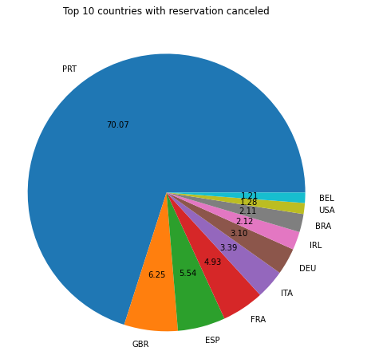

Let's look at how guests are booking their hotel stays. Are they doing it directly, through groups, or via online or offline travel agents? It turns out, almost half of the customers (46%) book through online travel agencies, while 27% do so through groups. Interestingly, only a small portion (4%) book directly by visiting the hotels and making their reservations.

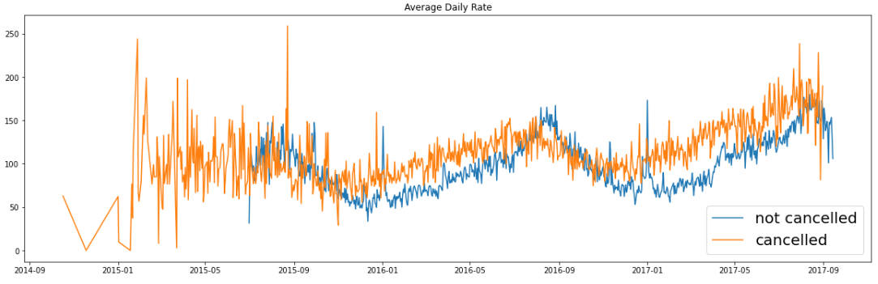

The graph shows that more bookings are canceled when the average daily rate is high compared to when it's low. This confirms our previous analysis - higher prices result in more cancellations.

# Recommendations

1. As cancellation rates tend to increase with rising prices, hotels could revise their pricing strategies to reduce cancellations. Lowering rates for certain hotels based on their locations and offering discounts could be effective.
2. The cancellation rate for resort hotels is higher than that for city hotels. Therefore, providing reasonable room price discounts, particularly on weekends or holidays, could help.
3. January sees the highest cancellation rate. Hotels could launch campaigns or marketing initiatives during this month to boost their revenue.
4. Improving the quality of hotel services, especially in Portugal, could help lower the cancellation rate.